A TECHNICAL REPORT ON STUDENT INDUSTRIAL WORK EXPERIENCE SCHEME (SIWES)

AT

BORNO STATE RADIO TELEVISION,
MAIDUGURI, BORNO STATE

FROM: OCTOBER, 2024
TO: JANUARY, 2025

TITLE PAGE

BY
SANUSI SULEIMAN CHUL
ET/COE/ND/23/011

A SIWES REPORT SUBMITED TO THE DEPARTMENT OF COMPUTER ENGINEERING, SCHOOL OF ENGINEERING AND TECHNOLOGY FEDERAL POLYTECHNIC, MUBI ADAMAWA STATE, NIGERIA

IN PARTIAL FUFILMENT OF THE REQUIREMENTS FOR THE AWARD OF NATIONAL DIPLOMA (ND) IN COMPUTER ENGINEERING

APRIL, 2025

DECLARATION
I Sanusi Suleiman Chul hereby declare that I did my Industrial Attachment Program at Borno State Radio Television between Starting October 2024, to ending January 2025, and this report is prepared by me and submitted to the SIWES coordinator as required. I understand that all the information contained in this report are correct and will be penalized if found to be false. I also know that the SIWES coordinator may request for additional evidence as requested for reconciliation.

SANUSI SULEIMAN CHUL ……………………….
ET/COE/ND/23/011 Date/Sign

CERTIFICATION
This is to certify that Sanusi Suleiman Chul with a registration number ET/COE/ND/23/011 I undergo his/her industrial training SIWES at Borno State Radio Television. In Partial fulfillment of the requirements for the award of National Diploma (ND) in computer engineering, Federal Polytechnic, Mubi.

Mal. Adamu Umaru Faruku ……………………
Departmental Supervisor Sign/Date

Mal. Adamu Umaru Faruku ……………………
Departmental SIWES Coordinator Sign/Date

Engr. Mohammed K. Halidu ……………………
Head of Department Sign/Date

DEDICATION
I dedicate this technical report to my parents, my sisters and colleagues and to all those that supported me throughout me industrial training.

ACKNOWLEDGEMENTS
First and foremost, I give all glory, honor, and sincere appreciation to Almighty God, the source of my strength, wisdom, and perseverance throughout this industrial training journey. I also express heartfelt reverence to my Lord and Savior, Jesus Christ, for His divine guidance, grace, and unending mercy that sustained me through every stage of this experience.
I would like to extend my profound gratitude to all the staff and lecturers of the Computer Engineering Technology Department, Federal Polytechnic, Mubi, for their continuous support, encouragement, and the wealth of knowledge they have imparted to me. Your dedication to academic excellence played a crucial role in shaping my understanding and appreciation of the architectural field.
My deepest appreciation goes to my beloved parents for their unwavering love, financial support, and constant prayers. Your belief in me has been my greatest motivation and I remain forever grateful for your sacrifices and encouragement. I am also immensely thankful to my wonderful brothers and sisters, whose care, advice, and emotional support provided comfort and strength during my industrial training. Your encouragement kept me focused and determined to excel.
Special appreciation goes to my colleagues, friends, and fellow trainees, with whom I shared this journey. Your collaboration, assistance, and shared experiences made this training both productive and enjoyable. Finally, I thank all those who, in one way or another, contributed to the success of my Student Industrial Work Experience Scheme (SIWES). Your contributions, whether big or small, were deeply valued.
Thank you all.

TABLE OF CONTENTS
TITLE PAGE i
DECLARATION ii
CERTIFICATION iii
DEDICATION iv
ACKNOWLEDGEMENTS v
TABLE OF CONTENTS vi
ABSTRACT viii
CHAPTER ONE 1
INTRODUCTION 1
1.1 Aim and objective of SIWES 1
1.2 Brief history of SIWES and ITF in Nigeria 2
1.3 Significance of SIWES to students 2
1.4 Brief History of Organization 3
1.5 Organizational Chart of BRTV 4
CHAPTER TWO 5
WORK EXPERIENCE 5
2.1 Installation of Solar System 5
2.1.2 Site Assessment and Preparation 5
2.1.3 Mounting Structure Installation 6
2.1.4 Solar Panel Placement 6
2.1.5 Electrical Wiring and Connections 7
2.1.6 Inverter and Battery Installation 7
2.1.7 System Integration and Performance Testing 8
2.1.8 System Inspection and Safety Compliance 8
CHAPTER THREE 9
3.1 Soldering 9
3.1.1 Soldering a Resistor to a Printed Circuit Board 9
3.1.2 Soldering a Capacitor to a Printed Circuit Board 10
3.1.3 Soldering an Integrated Circuit (IC) to a PCB 10
3.2 Computer Repairs and Maintenance tools 11
3.2.1 Hardware Tools 11
CHAPTER FOUR 15
4.0 SUMMARY, CONCLUSION AND RECOMMENDATIONS 15
4.1 SUMMARY 15
4.2 CONCLUSION 15
4.4 RECOMMENDATIONS 15
REFERENCES 16

ABSTRACT
The report summarises the result of work done during my SIWES experience, the technical report consists of four chapters, which comprises of introduction, history and criteria’s of SIWES in chapter one followed by their aims and objectives, historical background, organizational structure of the organization in chapter two, while chapter three consist of the work actually carried out during the SIWES programme and lastly chapter four consist of the summary, conclusions and recommendation.

CHAPTER ONE

INTRODUCTION
The Students’ Industrial Work Experience Scheme (SIWES) was established in 1973 by the Industrial Training Fund (ITF) to address the gap between theoretical knowledge and practical skills among Nigerian tertiary institution graduates (ITF, 2010). Prior to its establishment, there was a growing concern among industrialists regarding the lack of practical experience among graduates, especially those in science and technology disciplines (Akinyemi, 2011). The SIWES program serves as a skills development initiative aimed at preparing students from universities, polytechnics, and colleges of education for real-world industrial environments. This initiative was designed to enhance students’ ability to apply their classroom knowledge to real-life situations, facilitate their transition to the workplace, and equip them with the necessary technical and operational skills. It provides students the opportunity to operate and interact with equipment and machines not commonly found in their schools (Oladele & Akintayo, 2013).
Before SIWES, employers found that graduates lacked job-ready competencies due to a lack of exposure to the practical side of their disciplines. This led to high unemployment and dissatisfaction with the quality of graduates being produced (Adegboye, 2012). The situation prompted the ITF to introduce the SIWES scheme in 1973/74 as a solution to the disconnect between classroom learning and workplace demands. Initially fully funded by the ITF, the financial burden led to the fund’s withdrawal in 1978. Consequently, the federal government transferred the scheme’s coordination to the National Universities Commission (NUC) and the National Board for Technical Education (NBTE) in 1979. Later in 1984, the supervision and implementation of SIWES were handed back to the ITF, which resumed full management of the program in July 1985 with federal government funding (ITF, 2010).

1.1 Aim and objective of SIWES
ITF initiates SIWES with the sole aim of: Exposing student with the practical experience related to the theoretical knowledge acquired in school. Bridging the gap between theoretical learning and practical work situation.
- To make industries/organization to have confidence in the abilities and capacities of the graduates. SIWES helps the industries to evaluate the prospective employees and give feedback to the institution.
- It helps the student to gain work and also have experience and confidence as a result if successful completion of a given job assigned to them.
- To enlist and strengthen the employers’ involvement in the institution activities and in the entire educational process of preparing the student for meaningful and productive employment into industries.
- It provides an avenue for student in the Nigerian University and Polytechnics to acquire industrial skill and experience in their course of study.
- Development for greater understanding in other people and proffers skills in human relations.

1.2 Brief history of SIWES and ITF in Nigeria
It was said by Dr. Azikiwe Nnamdi, the one president of Nigeria that the practice of work but they all have the same goal that they all want to achieve in countries like china. They established within the premises of institution to provide real life situation, lack of practical skill of locally trained engineers and technologies. the chine way and condition of SIWES is that all institution must give student real life working experience in industrial works. Lecturers are involved in the industrial activities rendering constant services. So, all these countries have their own way of conducting the scheme but all lye on the same goal. And in Nigeria, the history of SIWES can be traced by the history of IITF which is the backbone of SIWES. ITF was established in 1974 under degree of 47 of 1971. It was a body established by the Federal Government of Nigeria and was given responsibility of training indigenous Nigerians. The establishment of the body became necessary due to high demand of Nigeria to take up the vacant positions created in various sector of the economy after the colonial masters have departed. Therefore, the Federal Government discovered that it is easier to train students that are skilled in school to be trained and meet up with gaps in the Nigerian economy and a scheme was established to care for such training and it was named Student Industrial Work Experience Scheme (SIWES). In 1973, the national board of technical education (NBTE) made it compulsory for all the polytechnic students, be it federal or state.

1.3 Significance of SIWES to students
Principles taught in the classroom are vein forced given concrete applications on the industrial assignment and students is able to see the relevance of their students which increase their motivation. It helps in given students the knowledge on the types of work to do after his/her graduation. SIWES given students opportunity for a change of environment as they move their institution to the place of attachment which changes the routine types of environment to a word of work. It helps in connecting the institution and the industrial their relationship the introduction of SIWES.

1.4 Brief History of Organization
Borno Radio Television Corporation (BRTV) Maiduguri traces its origins to 1957, when it began as a provincial station relaying programs from the now-defunct NBC in Kaduna and Lagos. Initially limited to just an hour of local broadcasts daily, it gradually expanded its capacity following the installation of a Short Wave Transmitter in 1970. With the 1979 Decree No. 8, the station was handed over to the Borno State Government, leading to the establishment of Borno Radio Corporation (BRC) in 1980. A television counterpart, Borno State Television (BSTV), was created in 1983, and by 1984 both services were merged to form BRTV, operating with a staff strength of 330. Over the years, both the radio and television arms experienced various technological transformations, though infrastructural challenges such as outdated transmitters limited their reach. Today, BRTV operates from six main facilities across Maiduguri and transmits in multiple languages including Kanuri, Hausa, Fulfulde, Babur-Bura, Shuwa Arab, and English, catering to the diverse population of the region.
BRTV’s primary goal is to serve as a platform for disseminating government policies, promoting unity, and enriching the socio-cultural, political, and economic development of Borno State. The corporation operates through various departments including News and Current Affairs, Programmes, Engineering, Marketing, Administration, Accounts, and the newly created Directorates of Public Relations, Legal, and ICT. It broadcasts radio programs for 18 hours daily and television programs in two shifts — morning and evening — with weekend transmissions extending into the early morning. The station relies largely on generator-powered facilities and continues to serve as a vital medium for public enlightenment, cultural preservation, and community development.

1.5 Organizational Chart of BRTV
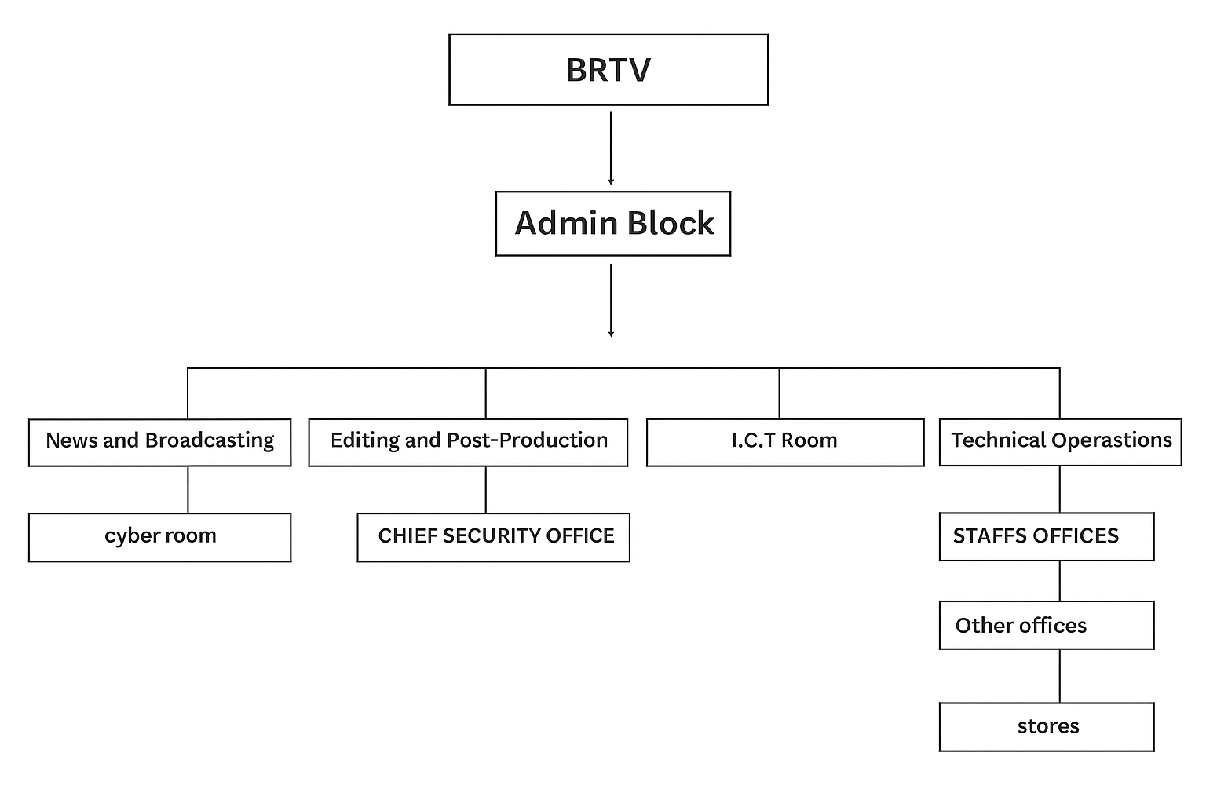
Figure 1.1: Organizational chart of Borno State Radio Television

CHAPTER TWO

WORK EXPERIENCE

2.1 Installation of Solar System
During my internship, I was privileged to observe and assist in the installation of a solar power system, which provided me with practical insight into renewable energy solutions. The process involved several key stages, all of which were crucial for the system’s performance, safety, and longevity. The installation began with a site assessment to determine the optimal location for the solar panels, usually on a roof or an open area with maximum exposure to sunlight. The site engineer evaluated the sun path, tilt angle, and potential shading issues. Once the best position was selected, we cleaned and prepared the surface for mounting.

2.1.2 Site Assessment and Preparation
Procedure:
The process began with inspecting the installation site to determine the most suitable location for the solar panels. The site engineer evaluated factors like sun exposure, roof tilt angle, shading from nearby objects, and structural integrity. Once the best location was identified, the surface was cleaned and cleared of any debris to prepare for mounting.
Tools Used:
- Solar irradiance meter
- Spirit level
- Measuring tape
- Marker pen or chalk
- Notebook or installation checklist
Safety Measures:
- Wore safety gloves and hard hats during roof inspection.
- Used a safety harness for rooftop access.
- Ensured ladder or scaffolding was placed on even ground and properly stabilized.

2.1.3 Mounting Structure Installation
Procedure:
The mounting frames were assembled and securely fastened to the roof using anchor bolts. Care was taken to align the structure at the correct tilt angle for optimal solar capture. The structure was tested for rigidity and resistance to wind loads.
Tools Used:
- Drill machine
- Spanners and wrenches
- Screwdrivers
- Spirit level
- Ladder or scaffolding
Safety Measures:
- Used safety harnesses and non-slip safety boots on the roof.
- Ensured tools were handled properly to prevent slips.
- Maintained a clean work area to reduce tripping hazards.

2.1.4 Solar Panel Placement
Procedure:
Solar panels were lifted onto the mounting structure using suction lifters or a pulley system. Each panel was aligned properly and fixed using clamps. Panels were placed to avoid shading and achieve uniform exposure to sunlight.
Tools Used:
- Panel suction cups or rope pulley system
- Spanners and clamps
- Spirit level
Safety Measures:
- Lifted panels with at least two people to avoid strain or accidents.
- Wore safety gloves and glasses to protect from sharp edges.
- Maintained proper footing and balance when working on height.

2.1.5 Electrical Wiring and Connections
Procedure:
Solar panels were electrically connected in series and parallel configurations based on the required system voltage and power output. Weatherproof connectors and junction boxes were used to ensure safe and durable connections.
Tools Used:
- Wire cutters and strippers
- Multimeter
- Crimping tool
- Electrical tape
- Junction boxes
- Cable ties
Safety Measures:
- Verified all connections were insulated to prevent short circuits.
- Checked voltage before handling wires using a multimeter.
- Avoided working on live wires and followed lockout/tagout procedures.

2.1.6 Inverter and Battery Installation
Procedure:
The inverter was mounted near the main distribution board. It was connected to the solar panel output and, where applicable, to a battery bank. A charge controller was installed between the panel and battery to regulate charging. The AC output from the inverter was connected to the building’s main power supply.
Tools Used:
- Drill machine
- Screwdrivers
- Wire cutters and strippers
- Multimeter
- Crimping tool
Safety Measures:
- Followed manufacturer guidelines for proper inverter spacing and ventilation.
- Turned off all power sources before making electrical connections.
- Wore insulating gloves while connecting live wires.

2.1.7 System Integration and Performance Testing
Procedure:
The entire setup was tested by turning on the system and monitoring voltage, current, and power output. Performance indicators were checked using testing instruments to ensure the system was functioning efficiently.
Tools Used:
- Multimeter
- Clamp meter
- Insulation tester
- Notebook for performance logs
Safety Measures:
- Avoided touching exposed terminals during live testing.
- Used insulated tools to measure live circuits.
- Stayed within safe testing voltage ranges.

2.1.8 System Inspection and Safety Compliance
Procedure:
A certified electrician inspected the entire system to verify it met local safety codes and standards. All wiring, connections, and components were reviewed to ensure no faults or risks remained.
Tools Used:
- Inspection checklist
- Multimeter
- Visual inspection tools
Safety Measures:
- Ensured system was shut down before the final inspection.
- Rechecked all safety gear and grounding of components.
- Maintained clear communication with the inspection team.

CHAPTER THREE

3.1 Soldering
During my internship, I had the opportunity to observe and participate in the soldering process, which is a key technique used for joining metal components, especially in electrical and plumbing installations. Soldering involves melting a filler metal (solder) to join two or more metal surfaces together, creating a strong electrical or mechanical bond once the solder cools and solidifies.

3.1.1 Soldering a Resistor to a Printed Circuit Board

Procedure:
The resistor leads were cleaned and inserted into the appropriate holes on the PCB. A small amount of flux was applied to the joints to aid solder flow and prevent oxidation. Using a preheated soldering iron, both the lead and pad were heated. Solder wire was then fed into the joint, allowing it to melt and bond the resistor securely to the board. After cooling, excess lead was trimmed and flux residue was cleaned. The joint was inspected to ensure it was neat and conductive.

Tools Used:
- Soldering iron
- Solder wire
- Resistor
- PCB
- Flux
- Side cutters
- Isopropyl alcohol
- Damp sponge

Safety Measures:
- Wore safety glasses and gloves
- Worked in a well-ventilated area
- Kept soldering iron in a safe stand when not in use
- Avoided direct contact with hot components
- Cleaned the workspace and removed flammable items

3.1.2 Soldering a Capacitor to a Printed Circuit Board

Procedure:
The capacitor’s leads were inserted into the correct holes on the PCB, observing polarity for electrolytic types. Flux was applied to the solder pads. A soldering iron was used to heat the pad and lead, and solder wire was fed into the joint to form a clean connection. After cooling, the excess leads were trimmed and the area cleaned of flux residue.

Tools Used:
- Soldering iron
- Solder wire
- Capacitor
- PCB
- Flux
- Side cutters
- Isopropyl alcohol

Safety Measures:
- Wore safety glasses and gloves
- Avoided touching hot components
- Ensured proper ventilation
- Used insulated tools
- Verified capacitor polarity before soldering

3.1.3 Soldering an Integrated Circuit (IC) to a PCB

Procedure:
The IC was carefully aligned with the socket or PCB pads. Flux was applied to all pins. Using a fine-tipped soldering iron, each pin was soldered individually with minimal solder to prevent bridging. After cooling, the joints were inspected for cold solder or shorts, and cleaned if necessary.

Tools Used:
- Soldering iron (fine tip)
- Solder wire
- IC chip
- Flux
- Desoldering braid (if needed)
- Magnifying glass or inspection lens

Safety Measures:
- Wore eye protection
- Handled ICs with ESD precautions (e.g., anti-static wrist strap)
- Avoided overheating pins
- Ensured proper ventilation
- Used precise tip and minimal solder to avoid shorts

3.2 Computer Repairs and Maintenance tools
To accurately and easily troubleshoot a system, a computer engineering needs to possess all the basic tools required for computer maintenance and other relevant tools also. But first proper precautions should be taking like;
Some of these tools include;
- Putting all component to be worked on, on an insulated table
- Always be careful of other close component
- Do not work on a live board.

3.2.1 Hardware Tools
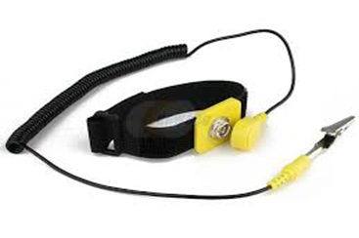
- Anti-static wrist band: The computer is made up of some of components that require very little electric charges to operate. The static electricity in the body may be far greater than the required charge, thus the destruction of such component. The anti-static wrist strap is used to prevent static electricity charges from destroying the computer parts by grounding your body. The metal clip is connected to a bare metal part of the computer case like the metal case of a PC.

Fig 2.1: Anti-static wrist band
This can also be achieved partially but no safely by touching the ground at intervals to Discharge the static electricity to the ground.
- Tweezers: It is a too; used for picking up and manipulating objects too small to be handled with the human hand.
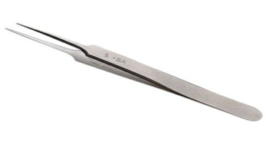
Fig 2.2: A tweezers
- Long Nose Plier: It used to cut wires and can get in and out of tight spots, unlike regular pliers.
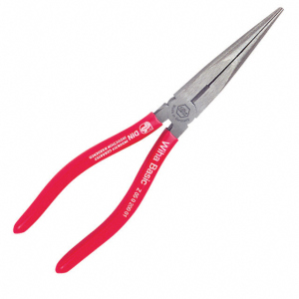
Fig 2.3: A plier
- Soldering Iron: It is essential for repairs on mother board but with extreme care. When used carelessly, it can destroy the board as well as injure the engineer.
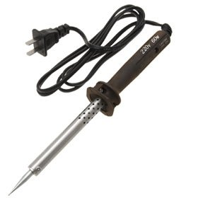
Fig 2.4: Soldering Iron
- 8” Wire Cutter/ Stripper: It is for wire cutting and stripping insulation on a single, multiple, fine stranded of wire cables with plastic or rubber insulation.
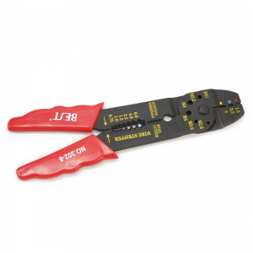
Fig 2.5: 8” wire cutter
- Hot air blower/Rework Station: This is used in desoldering parts that are faulty or have been being wrongly soldered. It weakens the lead. It is also used in the application of paste (heat dependent gum) on board.
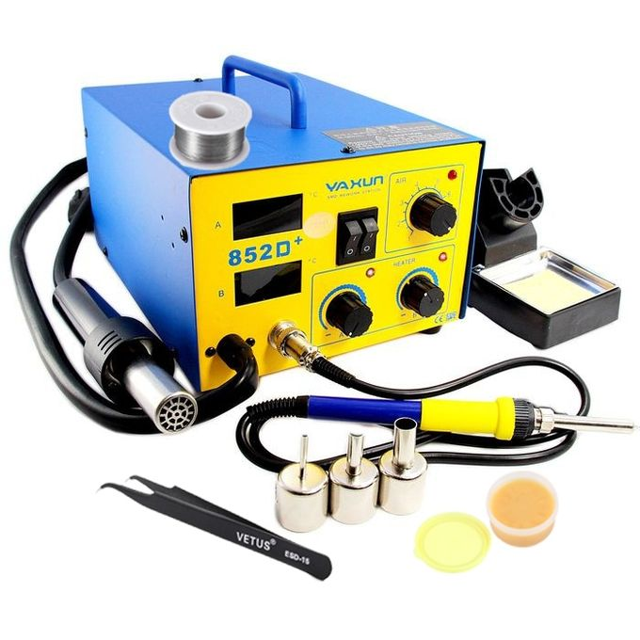
Fig 2.6 Hot air blower
- Set of Screw Drivers: The different parts of the computer are made of nuts and screws of different sizes, thus the need for multi-mouth screw driver set. It is used in the loosening of nuts and screws.
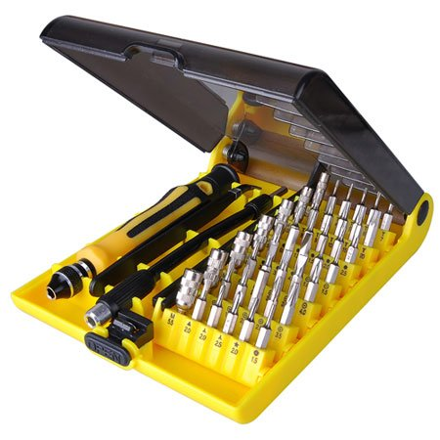
Fig 2.7: Set of screw drivers
- Paste flux: This is a heat dependent non-insulating joining paste used to attach components on the board.
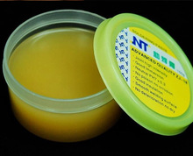
Fig 1.8: Paste flux
- Soldering wire/ lead: This is a metallic conductive joining material. It is applied using the soldering iron at high temperature. Soldering on the motherboard requires a high level of care as the soldering iron lacks precision(mouth-size of 2mm-3mm)
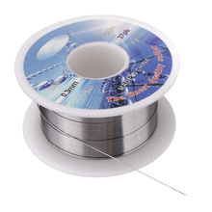
Fig 2.9: Soldering lead
- Multi-meter: It is used to measure voltage, current, continuity of wire or motherboard, resistances at different points on the board and a lot more.

Fig 2.10: A digital multi-meter
- Storage (USB Flash and External Hard disk): This stores all the engineer’s working soft wares. Without which the engineer can do so little.
- Magnifying Lamp: It is used while working on the board to magnify the size of the board for accuracy and speed.

Fig 2.11: A magnifying lamp

CHAPTER FOUR

4.0 SUMMARY, CONCLUSION AND RECOMMENDATIONS

4.1 SUMMARY
One would state that the discipline is the training of the mind and body towards effective performance. The Students Industrial Work Experience Scheme (SIWES) is more or less achieving this fit. As it further builds on the theoretical classrooms leaving a practical approach of the industry and commerce to supply of finished goods and services. This program has enabled the participating students to be practically involved in the day-by-day activities of the industries and commerce.
Emphasis in the observation of industrial safety rules and regulations, time critical operation and proper man-hand management, quality cortices, etc. are daily activity objective. All those aimed at the production of marketable goods and services in the world of work.
However, to consolidate on the gains of this Industrial Training Fund (ITF) higher institution coordinator on SIWES program should be allowed making some suggestion and recommendation.

4.2 CONCLUSION
SIWES programme is very vital student especially undergraduates, because I come to see the SIWES programme provide an application of the theoretical knowledge learned by student in school to practical or real work situation. Also, it is a medium where student from different higher institutions and department come together sharing idea there, by promoting an avenue for learning and them work.

4.4 RECOMMENDATIONS
Having being exposed to a bit of what entail working in an individual related to my course of study under SIWES programme I wish to make this recommendation
- Higher instruction of learning especially either institution and universities should establish link with comprise and establishment so as to provide space for student on industrial attachment, with the option of gaining employment in future, by doing so, it will go a long way in alleviating suffering and difficulties encountered by student in securing place for individual attachment.
- Student should not put money as the primary aim of going for SIWES programme, as there is more to learn.

REFERENCES
Adegboye, R. O. (2012). Challenges of industrial training in Nigeria. Lagos: Yaba College Press.
Akinyemi, S. (2011). Bridging the skills gap in Nigerian higher institutions: The SIWES approach. Nigerian Journal of Educational Research, 14(3), 22–29.
Industrial Training Fund (ITF). (2010). SIWES Policy Document. Jos: ITF Publications.
Oladele, J. O., & Akintayo, M. O. (2013). Effectiveness of the Students’ Industrial Work Experience Scheme (SIWES) in Nigerian tertiary institutions. Journal of Technical Education and Training, 5(1), 35–42.

